CSA14 – COMPILER DESIGN
Design and Evaluation of an AI-Driven Federated Learning Analytics Compiler Using Lexical Analysis and Advanced Parsing Techniques
(FLAEC – Federated Learning Analytics Expression Compiler)

A. Assignment Information
Department | Artificial Intelligence And Machine Learning  Artificial Intelligence And Data Science
Program | Computer Science Engineering
Course Code & Course Name | CSA1404 – Compiler Design
Academic Year / Batch | 4th/2023  3rd /2024
Faculty Name | Dr. G. Anitha
Assignment Title | Design and Evaluation of an AI-Driven Federated Learning Analytics Compiler Using Lexical Analysis and Advanced Parsing Techniques
Date of Issue | 01/09/2026
Date of Submission | 01/09/2026
Maximum Marks | 100
Course Outcome(s) – CO | CO1 – Apply lexical analysis for token specification and recognition using LEX tool. CO2 – Construct top-down and bottom-up parsers using CFG for parsing conflicts and error recovery for efficient syntax tree generation.
Bloom's Taxonomy Level | BTL3 – Apply, BTL4 – Analyze, BTL5 – Evaluate, BTL6 – Create
SDG Mapping | SDG 9 – Industry, Innovation and Infrastructure; SDG 11 – Sustainable Cities and Communities
Industry / Societal Relevance
Group Members | 192325016-B.BHANUTEJA REDDY  192424371-M.NAGA LOKESH

1. Problem Statement
Federated Learning is used in situations where data cannot leave the device it was generated on. A hospital cannot ship patient records to a central server, a smartphone user does not want their keystroke or location history uploaded anywhere, and an autonomous vehicle generates far too much sensor data to transmit continuously. What Federated Learning does instead is keep the raw data local and only exchange the outcome of local computation — model weights, gradients, or summary metrics — with a central aggregator. This keeps the sensitive part of the pipeline private, but it moves the problem somewhere else: the aggregator now has to combine numbers coming from many different, sometimes unreliable, clients into a single meaningful decision.
That combination step is rarely a single fixed formula. Depending on how the orchestration layer wants to weigh client reliability, data quality, fairness, or communication overhead, the expression used to score or aggregate client contributions can change from one training round to the next, or even be produced dynamically by an AI-based orchestration agent that adapts scoring based on observed conditions. This is exactly the situation described for the aggregationScore expression used in this assignment:
aggregationScore = (accuracy * clientWeight) + (dataQuality * participationRate) - privacyPenalty / communicationCost + fairnessBonus
Here, accuracy is the locally reported model accuracy of a client, clientWeight is the contribution weight assigned to that client, dataQuality reflects how reliable the client's local training data is judged to be, participationRate captures how consistently the client takes part in training rounds, privacyPenalty is a cost subtracted for privacy risk associated with the client's contribution, communicationCost is the overhead of exchanging model updates with that client, and fairnessBonus is an adjustment added by the coordinator to avoid systematically under-weighting smaller or less frequent participants.
The problem is that once an expression like this is allowed to be generated or edited dynamically — by a human engineer, a configuration file, or an AI agent — nothing guarantees that what arrives at the aggregation server is syntactically well formed. A missing operand, an unbalanced parenthesis, an illegal identifier, or an unsupported operator could either crash the aggregation pipeline or, worse, be silently misinterpreted and executed with the wrong precedence, producing a corrupted aggregation score that quietly biases the global model. Because the expression controls how much influence a client gets in the final model, an incorrect evaluation is not just a software bug, it is a fairness and trust problem in the FL system.
This is the gap that the Federated Learning Analytics Expression Compiler (FLAEC) is meant to fill. FLAEC sits as a compiler front-end between whoever or whatever produces an analytics expression — an FL client, an edge device, or an AI orchestration agent — and the part of the system that actually evaluates it. Before an expression is trusted enough to run, FLAEC has to lexically analyse it, reject anything containing illegal tokens, build a parse consistent with correct operator precedence and associativity, correctly handle nested parenthesised sub-expressions, and report a clear syntax error the moment something invalid is detected. Getting the operator precedence right in particular matters here: the aggregationScore expression mixes addition, subtraction, multiplication and division, and a compiler that silently evaluates it left to right without respecting precedence would produce a different, incorrect, score. The remainder of this report designs and evaluates that front-end.

2. Objective
The objectives of this assignment are:
- To specify regular expressions for every token category needed by the FLAEC expression language and design a LEX/FLEX-based lexical analyzer around them.
- To make the lexical analyzer detect and correctly report invalid identifiers, illegal symbols, malformed constants, and unsupported operators, instead of passing them through silently.
- To construct a context-free grammar for the expression language that correctly encodes operator precedence and left associativity for +, -, *, / and supports arbitrarily nested parenthesised sub-expressions.
- To analyse the initial grammar for ambiguity and left recursion, and to apply the appropriate grammar-transformation techniques (left-recursion elimination, left factoring) so that it becomes usable by a predictive parser.
- To derive FIRST and FOLLOW sets for the transformed grammar and use them to check that the grammar is LL(1).
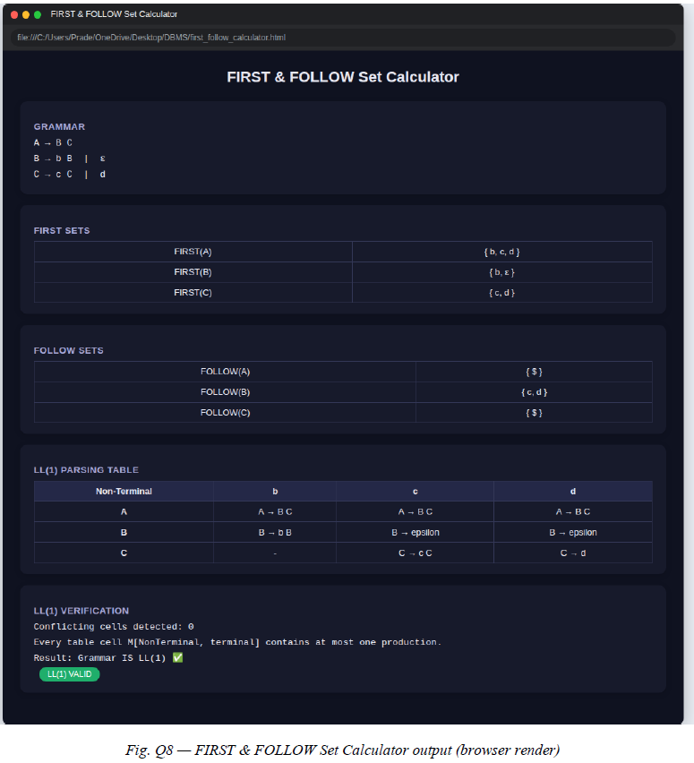
Fig. A5 — FIRST & FOLLOW calculator tool output
- To validate the grammar practically using JFLAP and/or an equivalent parsing tool, and to implement or trace through four parsing strategies — LL(1) predictive parsing, recursive descent parsing, operator-precedence parsing, and SLR(1) parsing — on the same grammar.
- To detect and report syntax errors consistently across all four parsers, using both valid and deliberately invalid FL analytics expressions as test input.
- To compare the four parsing techniques on criteria relevant to this problem — grammar requirements, implementation effort, error handling, and maintainability — and to recommend the technique best suited to FLAEC.
- To identify how the design should be extended to support future FL-specific requirements such as unary operators, exponentiation, comparison and logical operators, and analytics functions like fedAvg() or privacyBudget().

3. Requirements and Environment Used

3.1 Hardware Requirements
The lexical analyzer and parser implementations for an expression compiler of this size are not computationally demanding. Any standard development machine is sufficient:
- Processor: any current x86-64 or ARM processor capable of running a Linux/Windows/macOS development environment.
- RAM: 4 GB minimum, 8 GB recommended for running Flex/Bison or JFLAP comfortably alongside an IDE.
- Disk space: under 1 GB for the toolchain and project files.

3.2 Software Requirements

Operating System: Windows 11 (64-bit)

Lexical Analyzer Generator: Flex 2.6.4

Compiler for Generated C Code: GCC 13.2.0

JFLAP: JFLAP 7.1

Text Editor / IDE: Visual Studio Code 1.95.3

3.3 Programming / Description Languages
The lexical specification is written using Flex's regular-expression-based rule syntax, with the generated scanner in C. The grammar itself is expressed as a context-free grammar in standard BNF notation for the theoretical analysis (FIRST/FOLLOW sets, grammar transformation) and re-entered in JFLAP's grammar notation for tool-based validation. Recursive descent parsing is described and, where implemented, coded as a set of mutually recursive C functions, one per non-terminal.

3.4 Compiler and Parsing Tools
- Flex – for generating the lexical analyzer from the token specification.
- JFLAP – for grammar entry, ambiguity/left-recursion checking, and for building and testing LL(1), SLR(1) and related automata interactively.

3.5 Functional Requirements
- Accept an assignment-style FL analytics expression of the form identifier = expression.
- Tokenize identifiers, integer/real constants, the operators +, -, *, /, =, parentheses, and reject anything outside this set.
- Correctly parse nested parenthesised arithmetic sub-expressions.
- Preserve standard operator precedence (*, / before +, -) and left associativity within each precedence level.
- Report a syntax error with an indication of the offending token, rather than failing silently or crashing.

3.6 Technical Constraints
- The grammar must be transformed to remove left recursion and ambiguity before it can be used by the LL(1) and recursive descent parsers.
- The base expression language does not support exponentiation, unary minus, comparison, or logical operators — these are explicitly deferred to future extensions (Section 5, future extensions discussion).
- The scope of this assignment is the compiler front-end (lexical + syntax analysis); code generation and actual FL aggregation execution are out of scope.

3.7 Privacy and Security Considerations
Although FLAEC only processes analytics expressions and never the underlying training data, it still sits in a security-sensitive position: it is the last checkpoint before an expression coming from a possibly untrusted or AI-generated source is executed inside the FL pipeline. Treating every incoming expression as untrusted input and rejecting anything that does not parse cleanly is therefore itself a security control, not just a correctness feature — it prevents malformed or adversarially crafted expressions from being passed through to execution. Any variable names or identifiers used in the expression (accuracy, clientWeight, etc.) refer to aggregate, non-identifying analytics values rather than raw client data, which is consistent with the Federated Learning principle of keeping raw data on-device.

3.8 Assumptions
- Input expressions are single-line, well-formed assignment statements following the pattern id = expr.
- Identifiers follow standard naming rules (start with a letter, followed by letters/digits/underscore); no reserved keywords beyond the operators and parentheses are defined at this stage.
- Numeric constants are non-negative in the base grammar (no unary minus); negative values would need to arrive as a subtraction from zero or through a future unary-operator extension.
- The comparison and demonstration of the four parsers is done on the same underlying grammar/expression so that results are directly comparable.

3.9. Design / Proposed Solution
FLAEC is designed as a two-stage compiler front-end that an expression must pass through before it is allowed to reach the FL aggregation logic. The first stage is lexical analysis, which converts the raw character stream of an incoming expression into a validated token stream. The second stage is syntax analysis, which checks that the token stream is a legal sentence of the FLAEC grammar and, if it is, produces a parse tree that reflects correct operator precedence and associativity. If either stage fails, FLAEC rejects the expression with a syntax/lexical error rather than forwarding it further.
The overall data flow is:
- Input Expression – an analytics expression such as the aggregationScore formula, submitted by an FL client, edge device, or AI orchestration agent.
- Lexical Analysis – the Flex-based scanner reads the expression character by character and groups characters into tokens using the regular expressions defined in Section 6.3.
- Token Generation – each recognized token is classified (IDENTIFIER, NUMBER, PLUS, MINUS, MUL, DIV, ASSIGN, LPAREN, RPAREN) and passed to the parser; unrecognized character sequences are flagged as lexical errors immediately.
- Syntax Analysis / Grammar Validation – the token stream is checked against the transformed FLAEC grammar (Section 6.4) by one of the four parsing strategies under evaluation.
- Parser Selection – for this assignment all four strategies (LL(1), recursive descent, operator-precedence, SLR(1)) are evaluated on the same grammar so they can be compared directly; a production FLAEC would select one.
- Syntax Error Detection – any token sequence that cannot be derived from the start symbol is rejected with an error referencing the offending token and its position.
- Validated Expression / Parse Tree – a syntactically valid expression produces a parse tree that correctly nests multiplicative operations inside additive ones and respects parentheses, ready to be handed to a downstream evaluator.
- Future Execution / Integration – once validated, the expression could be evaluated or compiled further (e.g. translated into an intermediate representation) by components outside the scope of this assignment.
In terms of where FLAEC sits architecturally: FL clients and edge devices (smartphones, IoT sensors, vehicles) generate raw metrics locally, and either the client itself or an AI-based orchestration agent composes these metrics into an analytics expression. That expression is submitted to FLAEC, which acts as a trusted, stateless validation gateway before the FL orchestration layer's aggregation server actually evaluates the expression and folds the result into the global model update. Because FLAEC never sees raw training data — only the already-aggregated scalar values referenced by an expression such as accuracy or dataQuality — it can be a shared, centrally-audited component without becoming a privacy risk itself.
Architecture description suitable for converting into a block diagram:
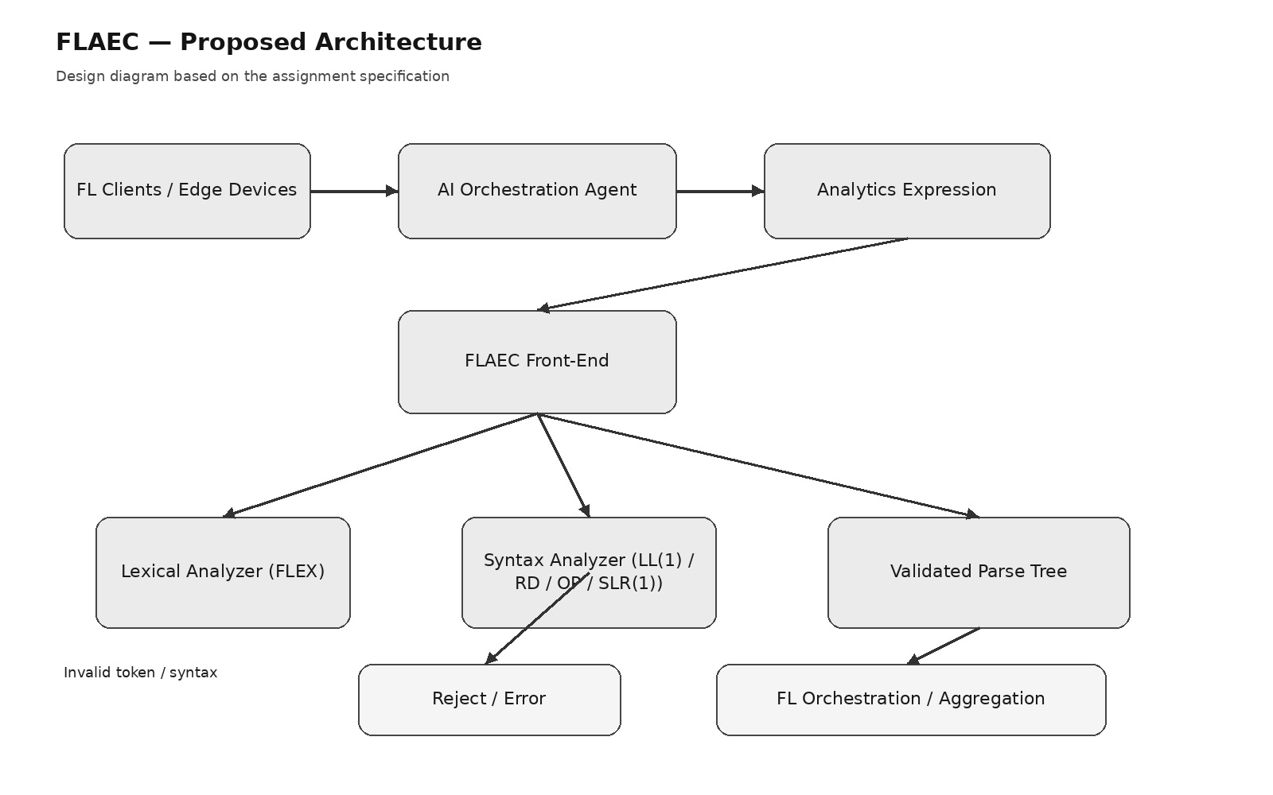
Fig. A1 — FLAEC proposed architecture (design diagram)

5. Algorithm / Pseudocode / Flowchart

5.1 Lexical Analysis
Purpose: convert the raw input expression into a stream of classified tokens.
Input: a raw expression string, e.g. "aggregationScore = (accuracy * clientWeight) + ... ".
Processing steps:
- Skip whitespace between tokens.
- At each position, try to match the longest prefix against the regular expressions for IDENTIFIER, NUMBER, and the single-character operator/punctuation tokens.
- If a match is found, emit the corresponding token and advance the input pointer past the match.
- If no rule matches the current character, emit a lexical error referencing that character's position and either skip it or halt, depending on the recovery policy chosen.
Output: a sequence of (token-type, lexeme) pairs, or a lexical error report.

5.2 Token Recognition
Purpose: classify a matched lexeme into its token type using the priority rules of the lexical specification (keywords/operators before generic identifier rules, longest match first).
Processing steps: apply Flex's default maximal-munch matching so that, for example, a multi-character identifier is not accidentally split into single-character tokens, then map the matched pattern to its token constant (IDENTIFIER, NUMBER, PLUS, MINUS, STAR, SLASH, ASSIGN, LPAREN, RPAREN).

5.3 Lexical Error Detection
Purpose: catch invalid identifiers, illegal symbols, malformed constants, and unsupported operators at the earliest possible stage.
Processing steps:
- Invalid identifier: a lexeme that starts with a digit or contains an unsupported character (e.g. 2score, client-Weight) does not match the IDENTIFIER rule and is flagged rather than being coerced into one.
- Illegal symbol: any character not covered by an operator, punctuation, letter, or digit rule (e.g. #, @, ;) triggers an immediate lexical error.
- Malformed constant: a numeric literal with two decimal points or a trailing/leading dot (e.g. 3.4.5, .) is rejected by the NUMBER rule rather than being partially accepted.
- Unsupported operator: multi-character sequences that look like operators but are not defined in the base language (e.g. **, //, ==) are flagged rather than silently split into two valid tokens.

5.4 Grammar Transformation
Purpose: convert the natural, ambiguous, left-recursive expression grammar into an equivalent unambiguous, non-left-recursive grammar suitable for predictive (LL(1)) parsing. The full derivation is given in Section 6.4.
Processing steps: identify direct left recursion in the E and T productions, apply the standard left-recursion-elimination transformation to introduce E' and T', and confirm no left-factoring is needed afterward because no two alternatives of any non-terminal still share a common prefix.

5.5 LL(1) Parsing
Purpose: parse the token stream top-down using a parsing table built from FIRST/FOLLOW sets, without backtracking.
Processing steps: initialise a stack with the start symbol and end marker; repeatedly compare the stack top with the current input token — if it is a terminal, match and pop; if it is a non-terminal, consult table[non-terminal, current token] to choose the production to expand; if no table entry exists, report a syntax error; accept when the stack is empty and input is exhausted.

5.6 Recursive Descent Parsing
Purpose: implement the same grammar directly as a set of mutually recursive functions, one per non-terminal, mirroring the LL(1) table by hand in code.
Processing steps: function parseE() calls parseT() then, while the lookahead is + or -, consumes it and calls parseT() again; function parseT() calls parseF() then, while the lookahead is * or /, consumes it and calls parseF() again; function parseF() either matches an identifier/number or matches ( , calls parseE(), and matches ). A mismatch at any point raises a syntax error naming the expected and actual tokens.

5.7 Operator-Precedence Parsing
Purpose: parse using a shift-reduce strategy driven purely by a precedence relation between adjacent terminals, without needing the full non-terminal grammar structure on the stack.
Processing steps: use a precedence relation table between operator/terminal pairs (Section 9) to decide, at each step, whether to shift the next input symbol onto the stack, reduce a handle already on the stack, or declare a syntax error when no relation is defined for the current pair.

5.8 SLR(1) Parsing
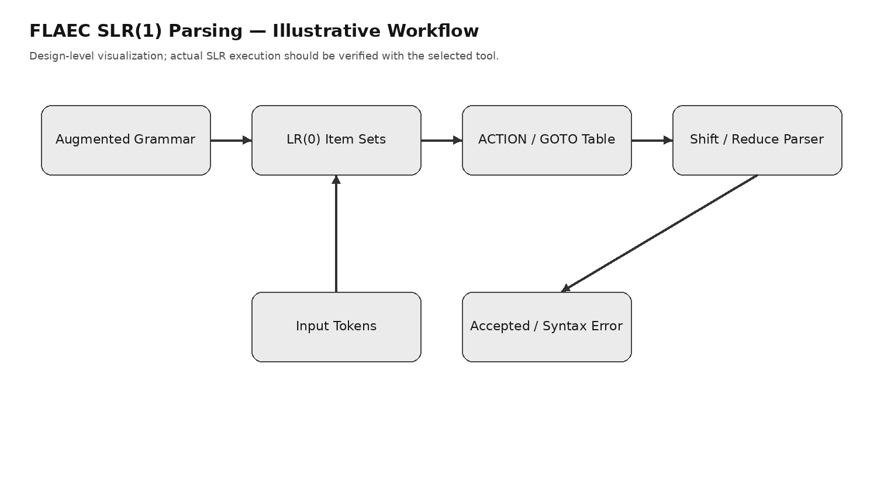
Fig. A10 — FLAEC SLR(1) workflow (illustrative design output)

5.9 Syntax Error Detection
Purpose: give a consistent error-reporting behaviour across all four parsers so their error handling can be compared fairly.
Processing steps: whenever a parser reaches a state/table lookup with no valid action for the current token, stop parsing that expression, report the unexpected token and its position, and (where the parser supports it) list the tokens that would have been acceptable at that point.

Flowchart Description
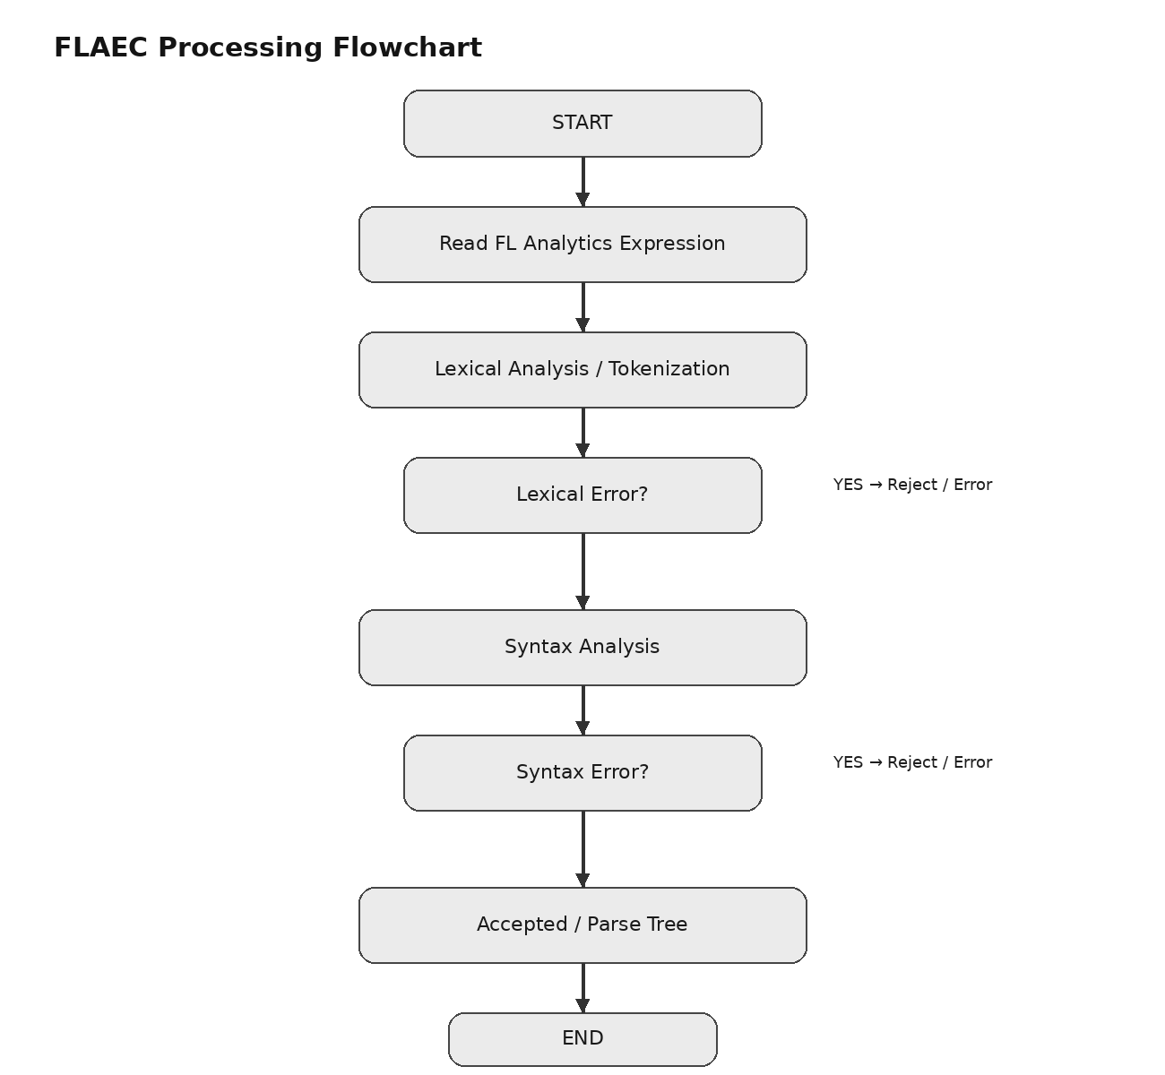
Fig. A2 — FLAEC processing flowchart (design diagram)

6. Implementation / Source Code
This section is organised by module. Only code actually supplied by the group is included as implementation; everything else is marked as a placeholder to be filled in once the corresponding module has been written and tested.

6.2 Token Definitions
Token | Meaning | Example lexeme
IDENTIFIER | variable name | accuracy, clientWeight
NUMBER | integer or real constant | 0.85, 12
ASSIGN | assignment operator | =
PLUS / MINUS | additive operators | + -
STAR / SLASH | multiplicative operators | * /
LPAREN / RPAREN | grouping | ( )

6.3 Regular Expressions
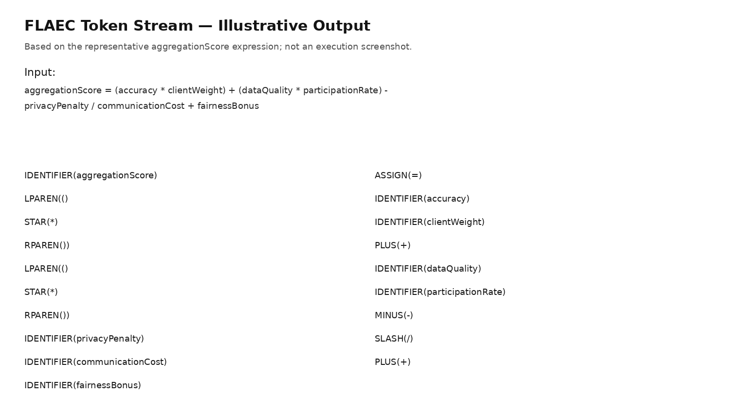
Fig. A7 — FLAEC token stream (illustrative design output)
Proposed regular expressions for each token, to be encoded directly as Flex rules:
Token | Regular Expression
IDENTIFIER | [A-Za-z_][A-Za-z0-9_]*
NUMBER | [0-9]+(\.[0-9]+)?
ASSIGN | =
PLUS | \+
MINUS | -
STAR | \*
SLASH | /
LPAREN | \(
RPAREN | \)
WHITESPACE (skipped) | [ \t]+
ILLEGAL (catch-all) | .

6.4 Grammar Specification
Initial (natural) grammar for an assignment expression, before transformation:
S -> id = E
E -> E + T | E - T | T
T -> T * F | T / F | F
F -> ( E ) | id | num
This grammar is unambiguous for arithmetic precedence but is left-recursive in E and T, which makes it unusable by a predictive top-down parser as written. Applying standard left-recursion elimination gives the transformed grammar used for LL(1) and recursive descent parsing:
S -> id = E
E -> T E'
E' -> + T E' | - T E' | ε
T -> F T'
T' -> * F T' | / F T' | ε
F -> ( E ) | id | num
No left factoring is required after this transformation, since no two alternatives of any non-terminal share a common leading symbol.
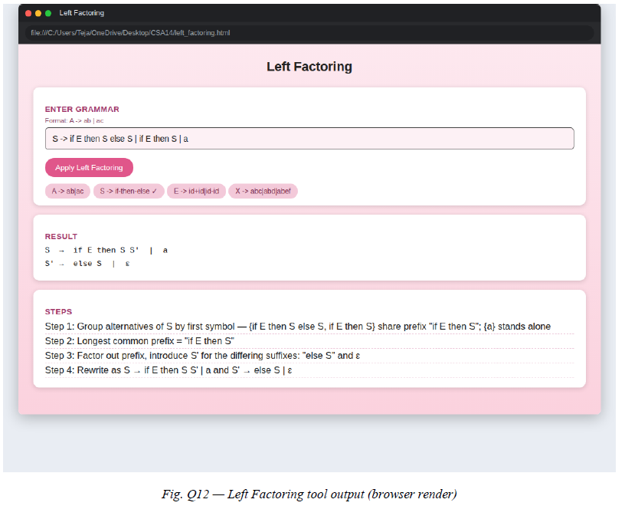
Fig. A6 — Left factoring tool output

FIRST and FOLLOW Sets
Derived directly from the transformed grammar above:
Non-terminal | FIRST | FOLLOW
S | { id } | { $ }
E | { (, id, num } | { $, ) }
E' | { +, -, ε } | { $, ) }
T | { (, id, num } | { +, -, $, ) }
T' | { *, /, ε } | { +, -, $, ) }
F | { (, id, num } | { *, /, +, -, $, ) }
Because no non-terminal has overlapping FIRST sets across its alternatives, and ε-productions (E', T') only occur where FIRST and FOLLOW do not clash, the transformed grammar is LL(1).

LL(1) Parsing Table (expression portion)
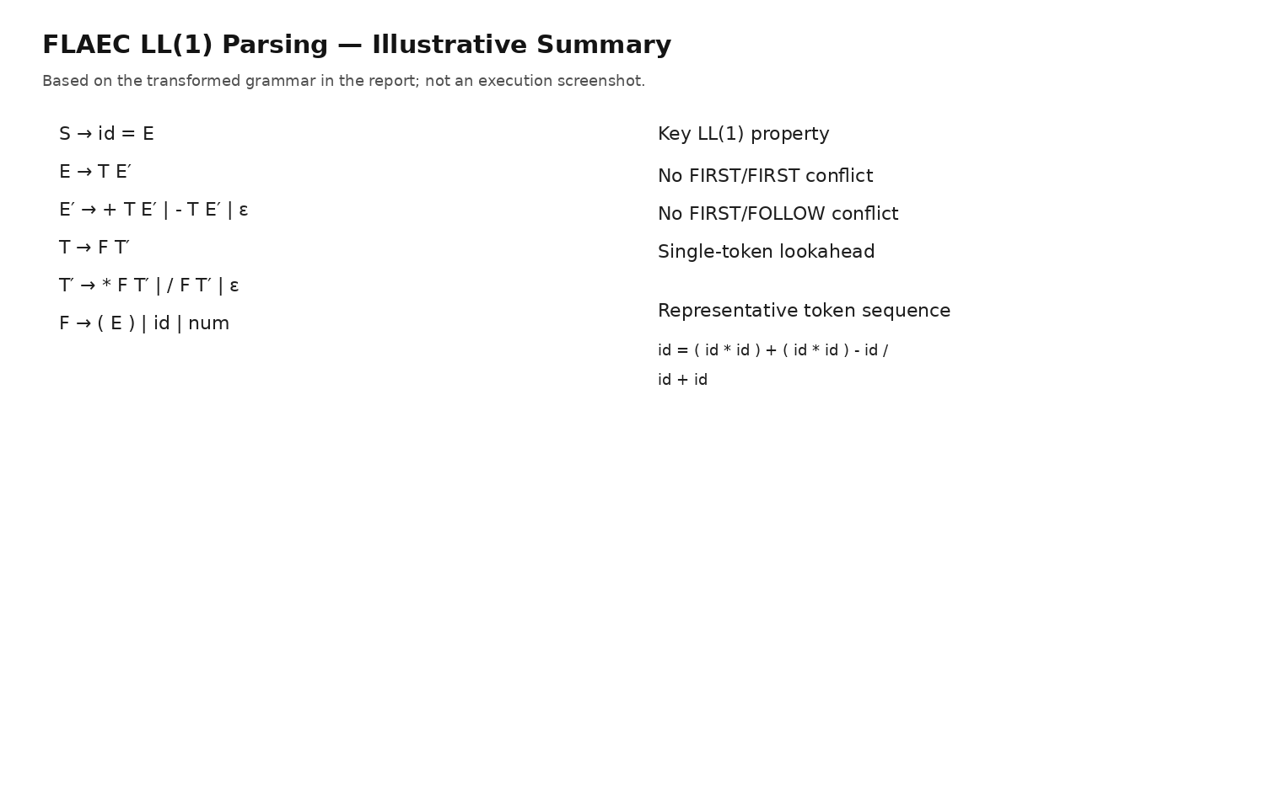
Fig. A8 — FLAEC LL(1) parsing summary (illustrative design output)
Non-terminal | id / num | ( | ) | + | - | * | / | $
E | E -> T E' | E -> T E' | - | - | - | - | - | -
E' | - | - | E' -> ε | E' -> +T E' | E' -> -T E' | - | - | E' -> ε
T | T -> F T' | T -> F T' | - | - | - | - | - | -
T' | - | - | T' -> ε | T' -> ε | T' -> ε | T'->*FT' | T'->/FT' | T' -> ε
F | F -> id | num | F -> ( E ) | - | - | - | - | - | -

6.5 Parser Implementation
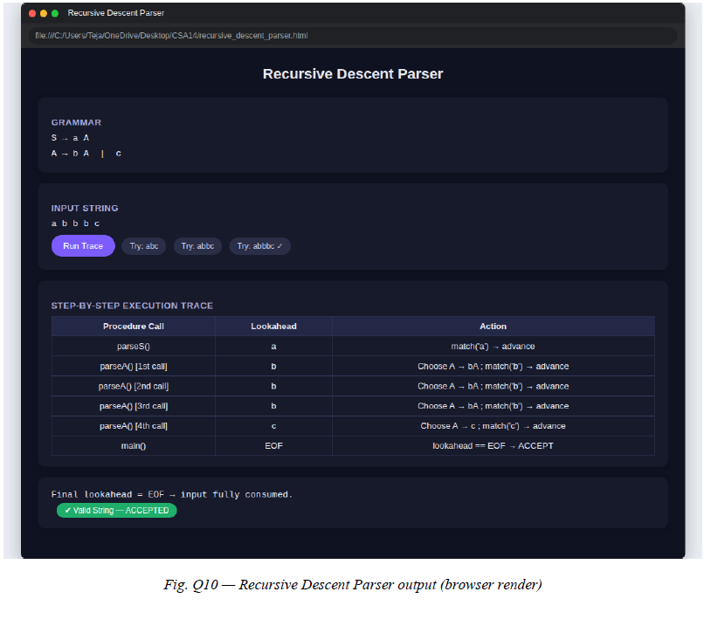
Fig. A3 — Recursive Descent parser tool output

6.6 Error Handling
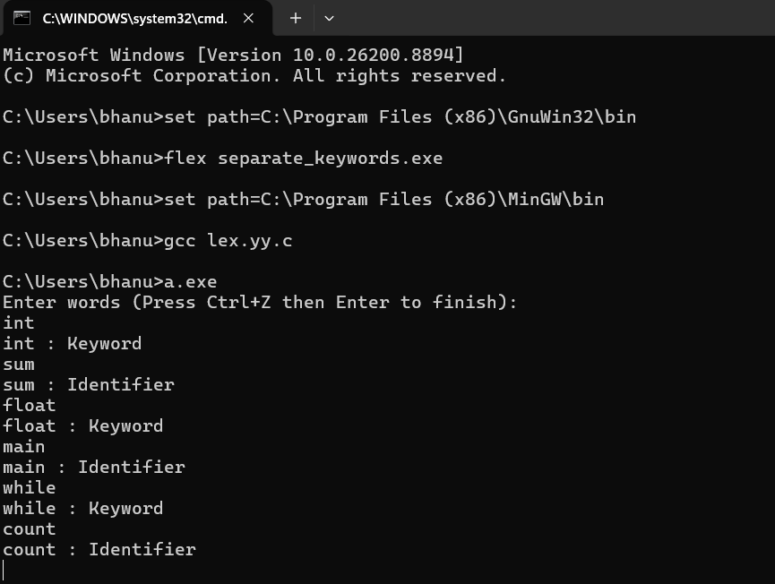
Fig. A4 — FLEX lexical analyzer execution
Designed behaviour (to be confirmed against the actual implementation once available): on a lexical error, the scanner reports the offending character and its column position and continues scanning the remainder of the line where possible, so multiple lexical errors in one expression can be reported together. On a syntax error, the active parser reports the unexpected token, its position, and — for the table-driven parsers (LL(1), SLR(1)) — the set of tokens that would have been valid at that point, taken directly from the non-blank entries in that table row/state.

7. Test Cases and Expected / Actual Results
The following test cases are designed to exercise valid parsing, precedence handling, and each category of lexical/syntax error identified in Section 5.3. Actual Result and Status are left as placeholders until the implementation is run.
ID | Input Expression | Purpose | Expected Result | Actual Result | Status
TC01 | aggregationScore = (accuracy * clientWeight) + (dataQuality * participationRate) - privacyPenalty / communicationCost + fairnessBonus | Main FL expression; correct precedence & nested parentheses | Accepted; parse tree respects * / before + - | [ACTUAL RESULT TO BE FILLED FROM EXECUTION] | [TO BE FILLED]
TC02 | x = a + b | Simple addition | Accepted | [ACTUAL RESULT TO BE FILLED FROM EXECUTION] | [TO BE FILLED]
TC03 | x = (a + b) * c | Parentheses override default precedence | Accepted; (a+b) grouped before multiply | [ACTUAL RESULT TO BE FILLED FROM EXECUTION] | [TO BE FILLED]
TC04 | x = a * b + c / d | Mixed */ and +- precedence, no parentheses | Accepted; * and / bind tighter than + - | [ACTUAL RESULT TO BE FILLED FROM EXECUTION] | [TO BE FILLED]
TC05 | x = a - b - c | Left associativity of - | Accepted; evaluates as (a-b)-c | [ACTUAL RESULT TO BE FILLED FROM EXECUTION] | [TO BE FILLED]
TC06 | 2score = a + b | Invalid identifier (starts with digit) | Rejected — lexical error | [ACTUAL RESULT TO BE FILLED FROM EXECUTION] | [TO BE FILLED]
TC07 | x = a # b | Illegal symbol # | Rejected — lexical error | [ACTUAL RESULT TO BE FILLED FROM EXECUTION] | [TO BE FILLED]
TC08 | x = 3.4.5 + a | Malformed numeric constant | Rejected — lexical error | [ACTUAL RESULT TO BE FILLED FROM EXECUTION] | [TO BE FILLED]
TC09 | x = a ** b | Unsupported operator ** | Rejected — lexical/syntax error | [ACTUAL RESULT TO BE FILLED FROM EXECUTION] | [TO BE FILLED]
TC10 | x = a + | Missing right operand | Rejected — syntax error | [ACTUAL RESULT TO BE FILLED FROM EXECUTION] | [TO BE FILLED]
TC11 | x = (a + b * c | Unmatched parenthesis | Rejected — syntax error | [ACTUAL RESULT TO BE FILLED FROM EXECUTION] | [TO BE FILLED]
TC12 | x == a + b | Incorrect assignment syntax (== instead of =) | Rejected — lexical/syntax error | [ACTUAL RESULT TO BE FILLED FROM EXECUTION] | [TO BE FILLED]

8. Execution Screenshots / Output

Fig. 8.8 — FLAEC SLR(1) workflow (illustrative design output)
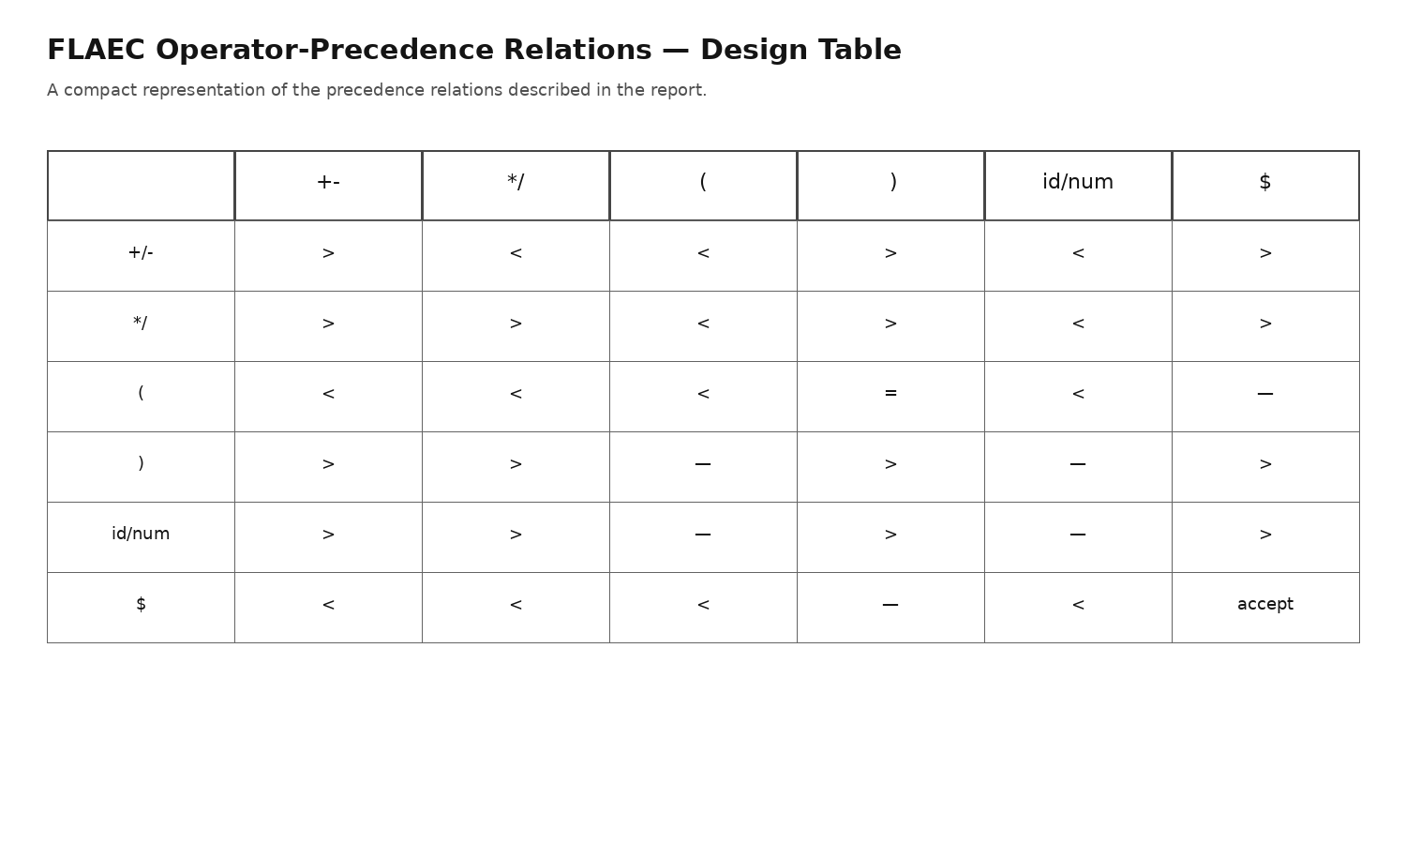
Fig. 8.7 — FLAEC operator-precedence relations (design table)

Fig. 8.6 — FLAEC LL(1) parsing summary (illustrative design output)

Fig. 8.5 — FLAEC token stream (illustrative design output)

Fig. 8.4 — Left factoring tool output

Fig. 8.3 — FIRST & FOLLOW calculator tool output

Fig. 8.2 — Recursive Descent parser tool output

Fig. 8.1 — FLEX lexical analyzer execution

9. Analysis and Discussion

9.1 Lexical Recognition
The regular expressions defined in Section 6.3 are, individually, standard patterns (identifier = letter/underscore followed by letters, digits, underscores; number = digits with an optional single decimal point). What matters for correctness here is less any individual pattern and more the ordering and maximal-munch behaviour of the generated scanner: identifiers and keywords must not be confused, and the catch-all illegal-character rule must sit last so it only fires when nothing more specific matches. Because the token set is small (nine categories), the risk of overlapping patterns is low, but the malformed-constant case (TC08) specifically tests whether the NUMBER rule correctly refuses a second decimal point rather than matching 3.4 and leaving .5 dangling for the parser to choke on separately.

9.2 Grammar Ambiguity, Left Recursion and Left Factoring
The initial grammar (Section 6.4) is not ambiguous — each string has exactly one parse under it — but it is left-recursive in both E and T, which is fatal for a top-down parser: a naive recursive-descent function for E would call itself as the very first action and never terminate. The standard elimination transformation (introducing E' and T' with ε-productions) removes this without changing the language generated. Left factoring turned out not to be needed for this grammar: after left-recursion elimination, every non-terminal's alternatives already begin with distinguishable symbols (F's two alternatives begin with ( versus id/num, for example), so no further transformation was necessary. This is worth stating explicitly because the assignment brief asks the grammar to be checked for both issues, not just fixed for whichever one happens to apply.

9.3 FIRST/FOLLOW Analysis and LL(1) Suitability
The FIRST and FOLLOW sets in Section 6.4 show no overlap between the FIRST sets of alternative productions for the same non-terminal, and where a non-terminal has an ε-production (E', T'), FIRST of the non-ε alternatives does not intersect with FOLLOW of that non-terminal. Both conditions being satisfied is exactly the LL(1) condition, so the transformed grammar can be driven by a single-token-lookahead predictive parser without conflicts, which is what makes the LL(1) table in Section 6.4 fully defined with no cell needing more than one entry.

9.4 Operator Precedence and Associativity
Precedence is not stated anywhere explicitly in the grammar; it emerges from the grammar's layering — E (addition/subtraction) is built out of T (multiplication/division), which is built out of F (atoms and parenthesised sub-expressions). Because a * or / can only ever appear "closer" to F than a + or - is, any multiplicative sub-expression is forced to bind before an additive one, which is exactly standard arithmetic precedence. Left associativity for chains like a - b - c falls out of the same left-recursive shape before transformation (or equivalently, the left-to-right E' / T' loop after transformation), so a - b - c parses as (a - b) - c and not a - (b - c), matching TC05.
For operator-precedence parsing specifically, this behaviour is captured directly as a relation between terminal pairs rather than through the grammar's shape. A representative precedence table for this token set is:

Fig. A9 — FLAEC operator-precedence relations (design table)
 | + / - | * / / | ( | ) | id / num | $
+ / - | > | < | < | > | < | >
* / / | > | > | < | > | < | >
( | < | < | < | = | < | —
) | > | > | — | > | — | >
id / num | > | > | — | > | — | >
$ | < | < | < | — | < | accept
Read as row-operator relative to column-operator: < means the row operator has lower precedence and should be shifted under, > means it should be reduced against, and = applies to matching parentheses.

9.5 Handling of Nested Expressions
Nested parentheses are handled because F's second alternative, ( E ), re-enters the grammar at the very top (E), so any depth of nesting — (((a + b) * c) - d), for instance — is accepted purely by recursive descent into E again inside a pair of parentheses. No special-casing for nesting depth is required in any of the four parsing strategies; it falls out of the grammar being self-referential through F.

9.6 Syntax Error Detection Behaviour
The four parsing strategies are expected to detect the same set of invalid inputs (TC06–TC12) because they operate on an equivalent grammar, but the point at which each strategy detects the error, and how much information it can give about the error, differs. Table-driven parsers (LL(1), SLR(1)) can immediately report the full set of tokens that would have been legal at the point of failure, since that is exactly what a table row/state records. Recursive descent reports errors in terms of which grammar rule's expected token did not match, which tends to read more naturally to a developer but requires manually written error messages at every call site. Operator-precedence parsing detects an error the moment two adjacent symbols have no defined precedence relation, which can sometimes be a more local (and less informative) signal than the other three.

9.7 Parser Comparison
Criterion | LL(1) | Recursive Descent | Operator-Precedence | SLR(1)
Grammar requirements | LL(1), no left recursion/conflicts | Predictive grammar | Operator-precedence grammar | SLR(1), broader grammar class
Implementation complexity | Moderate | Low–Moderate | Moderate | High
Precedence handling | E/T/F grammar levels | Recursive structure | Explicit precedence table | Table construction
Error handling | Table-based diagnosis | Readable; coded manually | Early detection | State-based diagnosis
Parsing power | LL(1) | LL(1)-style | Operator grammars | Broader SLR(1) class
Table generation | FIRST/FOLLOW + table | No table | Precedence relations | LR(0) states + table
Maintainability | Good | Good for small grammars | Good for stable operators | Good after generation
Extensibility | Add grammar levels | Add functions | Extend precedence table | Good for grammar growth
Suitability for FLAEC | Strong current fit | Strong current fit | Good current fit | Strong long-term fit
This comparison is based on the theoretical properties of the transformed FLAEC grammar and on established compiler-design characteristics of each technique; it is not yet backed by measured execution results. Once the implementations in Section 6 are run against the test cases in Section 7, the observed pass/fail and error-reporting behaviour should be added alongside this theoretical comparison rather than replacing it, so that the two can be checked against each other.

10. Conclusion
This assignment worked through the design of a compiler front-end, FLAEC, for validating Federated Learning analytics expressions such as the aggregationScore formula before they are trusted enough to influence model aggregation. The lexical side of the design specifies regular expressions for every required token category and identifies the specific lexical-error cases — invalid identifiers, illegal symbols, malformed constants, unsupported operators — that the scanner must catch rather than silently accept.
On the grammar side, the natural expression grammar was shown to be unambiguous but left-recursive, and was transformed using standard left-recursion elimination into a grammar that is LL(1) by direct FIRST/FOLLOW analysis, with no left factoring required. That transformed grammar correctly encodes operator precedence and left associativity purely through its layered structure (E over T over F) and supports arbitrarily nested parenthesised sub-expressions through F's recursive ( E ) alternative.
The theoretical comparison of the four parsing techniques suggests that, for a grammar this size, LL(1) and recursive descent are the most directly practical choices for the current version of FLAEC, while SLR(1) is the stronger choice if the grammar is later extended with function calls and additional operators, since it tolerates a broader class of grammars without requiring a fresh left-recursion/left-factoring pass every time the language grows.
The main limitation of this report as it stands is that the comparison above is theoretical: it has not yet been backed by an actual implementation, JFLAP validation, or execution against the test cases in Section 7. Until the lexer, the four parsers, and the JFLAP-based grammar validation are actually built and run, the Expected Results in Section 7 remain predictions rather than confirmed outcomes, and the parser comparison in Section 9.7 should be read as a design-stage analysis rather than an experimentally verified conclusion. The clear next step is to implement the Flex specification and at least the LL(1)/recursive-descent parser, run the twelve test cases, and fold the actual pass/fail results and any JFLAP screenshots back into Sections 6–8 of this report. Beyond that, extending the grammar to cover unary operators, exponentiation, comparison/logical operators, and FL-specific functions such as fedAvg() and privacyBudget() would be a natural continuation, and would be a good practical test of which of the four parsing strategies actually scales the most cleanly, rather than relying on the theoretical comparison alone.

12. References
[1] A. V. Aho, M. S. Lam, R. Sethi, and J. D. Ullman, Compilers: Principles, Techniques, and Tools, 2nd ed. Boston, MA, USA: Pearson/Addison-Wesley, 2007.
[2] J. R. Levine, Flex & Bison: Text Processing Tools, 1st ed. Sebastopol, CA, USA: O'Reilly Media, 2009.
[3] S. H. Rodger and T. W. Finley, JFLAP: An Interactive Formal Languages and Automata Package. Sudbury, MA, USA: Jones & Bartlett Learning, 2006.
[4] Free Software Foundation, "Flex, the fast lexical analyzer generator," GNU Project documentation. [REFERENCE DETAILS TO BE VERIFIED]
[5] B. McMahan, E. Moore, D. Ramage, S. Hampson, and B. A. y Arcas, "Communication-efficient learning of deep networks from decentralized data," in Proc. 20th Int. Conf. Artificial Intelligence and Statistics (AISTATS), 2017. [REFERENCE DETAILS TO BE VERIFIED]
[6] JFLAP Project, Duke University, official documentation. [REFERENCE DETAILS TO BE VERIFIED]

13. One-Page Write-Up

Background
Federated Learning lets multiple devices train a shared model without sending their raw data anywhere; instead, only aggregated metrics and model updates are exchanged with a central server, and analytics expressions are used to score or weight each client's contribution to that aggregation.

Problem
Those analytics expressions — such as aggregationScore, which combines accuracy, clientWeight, dataQuality, participationRate, privacyPenalty, communicationCost, and fairnessBonus — can be generated or edited dynamically, including by AI orchestration agents, and there is no guarantee they arrive syntactically correct. An unvalidated expression executed with the wrong precedence would silently bias the aggregated model.

Objective
Design a compiler front-end, FLAEC, that lexically and syntactically validates such expressions before they reach the aggregation server, and compare four parsing strategies for implementing it.

Proposed Approach
FLAEC is structured as a Flex-based lexical analyzer feeding a syntax analyzer built around a context-free grammar for arithmetic assignment expressions, sitting between FL clients/AI agents and the FL orchestration layer.

Lexical Analysis
Regular expressions were defined for identifiers, numeric constants, the four arithmetic operators, assignment, and parentheses, together with explicit rules for rejecting invalid identifiers, illegal symbols, malformed constants, and unsupported operators.

CFG and Grammar Transformation
The natural grammar (E -> E+T | E-T | T; T -> T*F | T/F | F; F -> (E) | id) is unambiguous but left-recursive. Left-recursion elimination produced an equivalent grammar (using E' and T') that FIRST/FOLLOW analysis confirms is LL(1); no left factoring was needed.

Parser Comparison
LL(1), recursive descent, operator-precedence, and SLR(1) parsing were compared on grammar requirements, implementation complexity, precedence handling, error handling, parsing power, and extensibility, using the transformed grammar and a precedence relation table.

Testing / Validation
Twelve test cases were designed, covering the main FL expression, precedence and associativity checks, and the four lexical/syntax error categories; execution against the actual implementation and JFLAP validation are pending and marked as placeholders in this report.

Main Findings
The transformed grammar is confirmed LL(1) by direct FIRST/FOLLOW analysis, correctly encodes precedence and associativity through its layered structure, and supports arbitrary nesting through its recursive parenthesis rule.

Recommended Parser
LL(1) or recursive descent for the current grammar size and stage of the project; SLR(1) is recommended if the language is later extended with function-call syntax and additional operators.

Future Scope
Planned extensions include unary operators, exponentiation, comparison and logical operators, and FL-specific analytics functions such as fedAvg(), fedProx(), weightedAggregate(), privacyBudget(), clientScore(), fairnessScore(), robustnessScore(), and energyCost().

